

 NAND GATE –

The NAND gate represents the complement of the AND operation. Its name is an abbreviation of NOT AND. The graphic symbol for the NAND gate consists of an AND symbol with a bubble on the output, denoting that a complement operation is performed on the output of the AND gate. The truth table and the graphic symbol of NAND gate is shown in the figure. The truth table clearly shows that the NAND operation is the complement of the AND.

NOT Gate using NAND Gate-

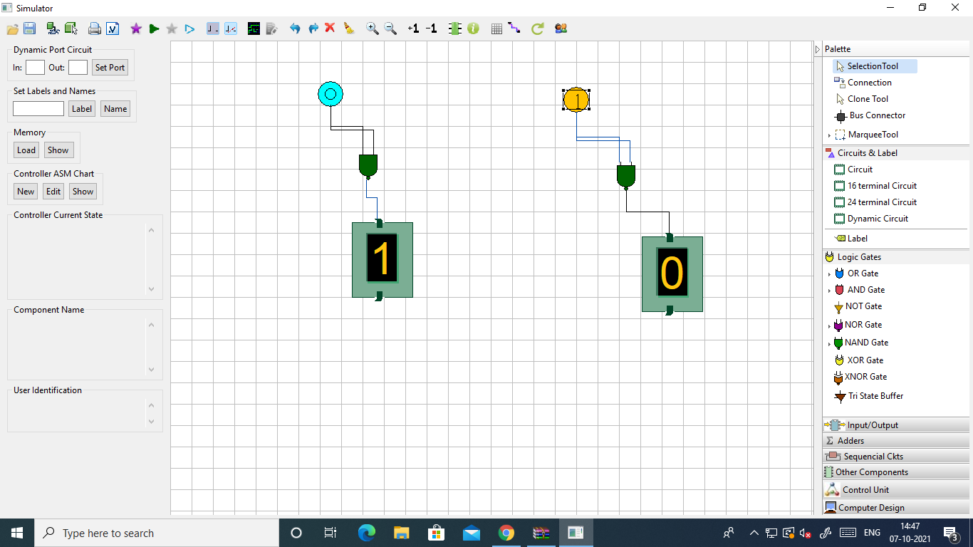

AND Gate using NAND Gate-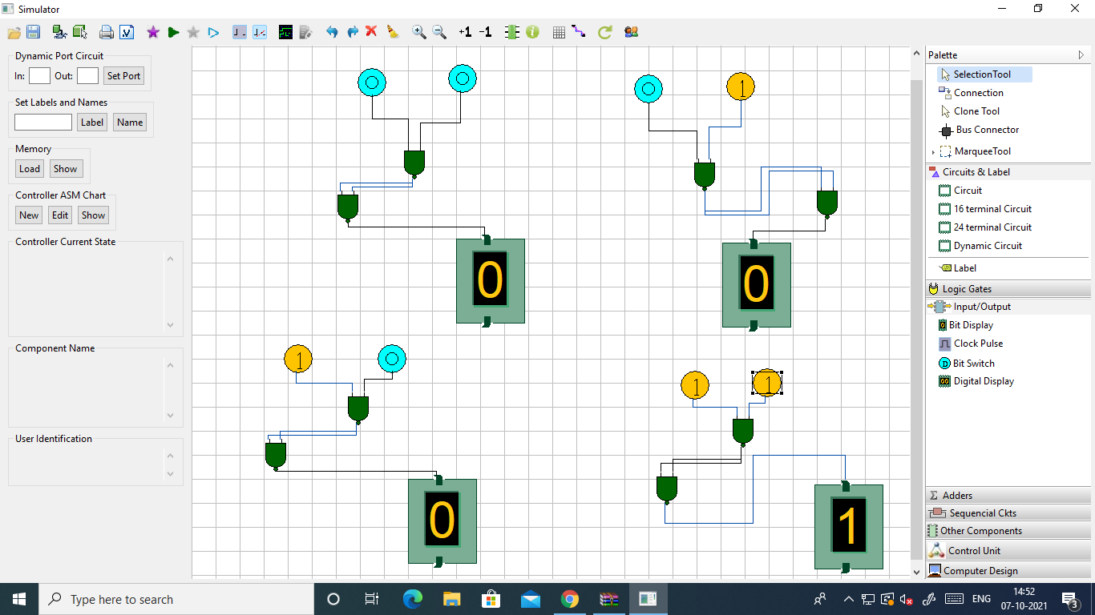OR

OR Gate using NAND Gate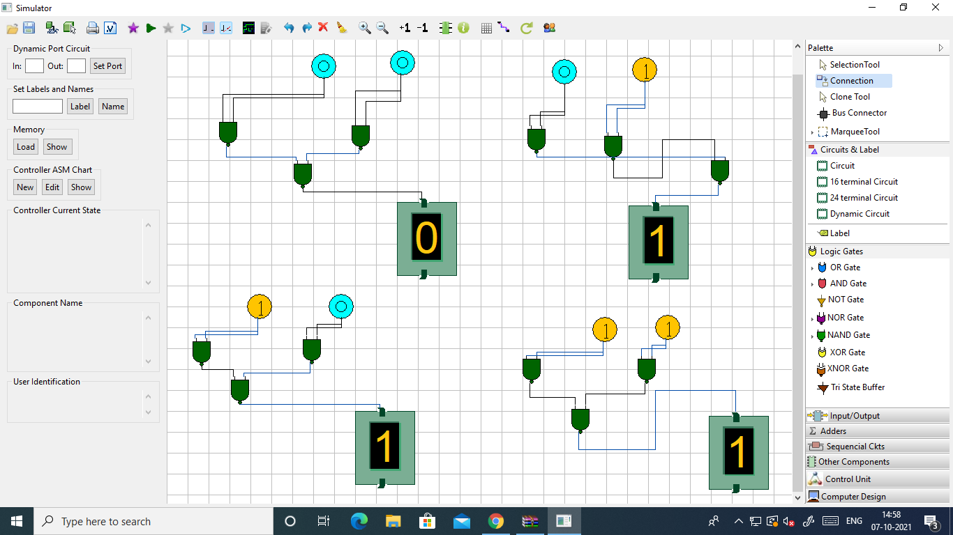

XOR Gate using NAND Gate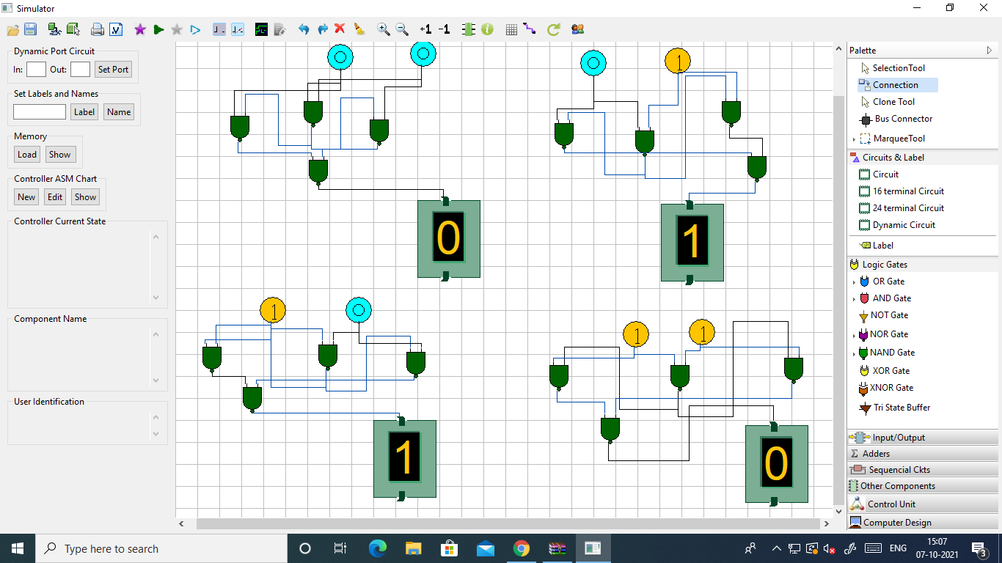

XNOR Gate using NAND Gate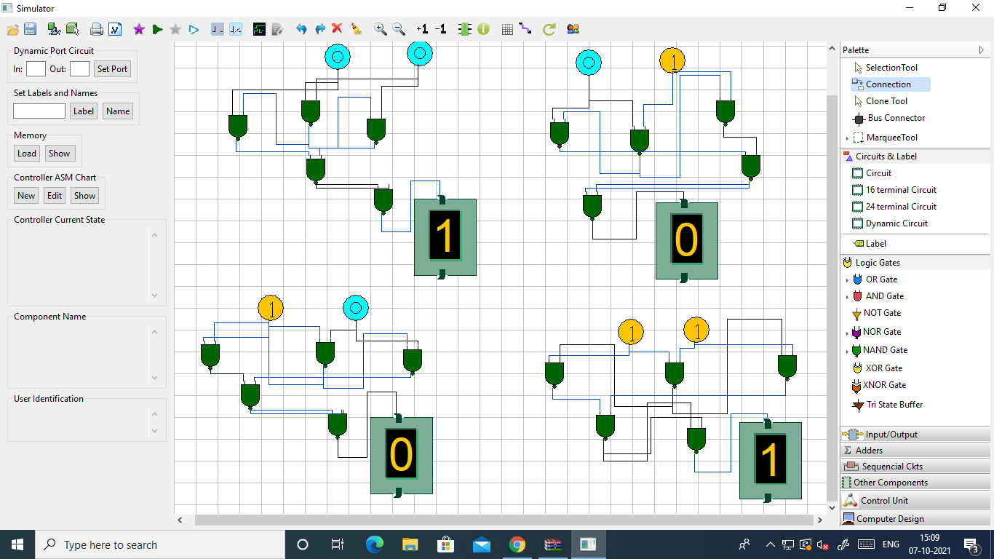

NOR Gate

The NOR gate represents the complement of the OR operation. Its name is an abbreviation of NOT OR. The graphic symbol for the NOR gate consists of an OR symbol with a bubble on the output, denoting that a complement operation is performed on the output of the OR gate. The truth table and the graphic symbol of NOR gate is shown in the figure. The truth table clearly shows that the NOR operation is the complement of the OR.

XOR GATE using NOR Gate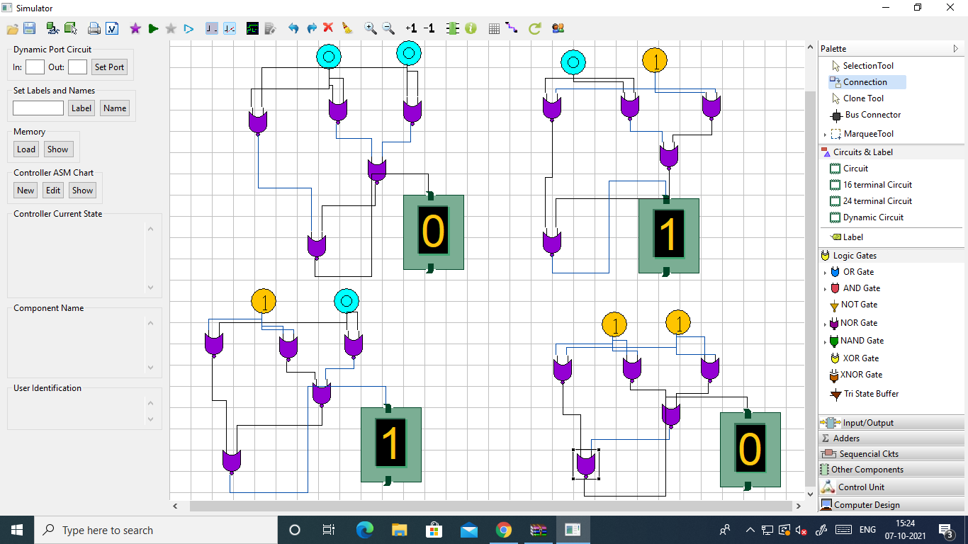

XNOR Gate using 